Draftwork Instructor Guide
How to set up an assignment, review the submissions and talk with your students
Draftwork 0.9 · October 2026
Written in ASD-STE100 Simplified Technical English.
The screenshots show sample data. Names and essays in them are not real.

Contents
About this guide
What you need
Where Draftwork keeps the data
How to use this guide
Quick reference
Make an assignment
More options
Change an assignment
Back up your assignments and notes
Back up automatically to a folder (Chrome and Edge)
Use your assignments on a different computer
Give the instructions to your students
Tell your students what to upload
Prepare the dropbox in your course site
See what your students see
Open the submissions
Find the submissions that need attention
Read a report
Read a flag
Types of flags
See how the work was written
The writing process graph
The replay
Talk with the student
Read the submitted document
Share with a colleague
Export a spreadsheet
If you have a problem
Words used in this guide

About this guide
This guide tells you how to use Draftwork with a class. It tells you how to set up an assignment, give the instructions to your students, open the submissions and review them.
Students write in Draftwork, a word processor that records how their writing comes together. They upload a .draftwork file to your course site. They can also upload a Word document, so that you can see the work in the preview of your course site. You open the files in Draftwork. Draftwork shows how each submission was written and gives you questions to ask.
CAUTION: Do not use a flag as evidence on its own. Draftwork does not decide who wrote a submission. A flag is a reason to ask the student a question. Use the conversation and the policy of your institution to make decisions.

What you need
- A computer with the Chrome web browser or the Microsoft Edge web browser. Automatic backup to a folder operates only in Chrome and Edge.
- A course site where you can make an assignment dropbox and download all submissions as one zip file.
- Optional: a folder in your institution OneDrive for automatic backups.

Where Draftwork keeps the data
- Your assignments and your check-in notes are kept in your web browser. Use automatic backup to keep a copy in a folder.
- Student work stays on the computer of the student until the student uploads it to your course site.
- When you open the submissions, Draftwork reads the files in your browser. It does not upload them.

How to use this guide
- Use the Quick reference for the full procedure on one page.
- Use the sections after the quick reference for the full procedures.
- Text in bold shows a name that you see on the screen, for example a button.
- In each screenshot, numbers in circles show the parts of the screen. A table after each screenshot tells you about each number.

Quick reference
Use this table as a job aid. Do the steps in this sequence.
Step | Where | Do this
1. Make the assignment | Draftwork: Assignments | Type the title, the due date and the dropbox link. Click Create.
2. Set up backups | Draftwork: Assignments | Select a folder for automatic backup, for example in OneDrive.
3. Give the instructions | Draftwork, then your course site | Click Instructions for students. Select what students upload. Copy the text. Paste it into the assignment in your course site.
4. Prepare the dropbox | Your course site | Make sure that the dropbox accepts the files that students upload.
5. Get the submissions | Your course site | Download all submissions as one zip file.
6. Open the submissions | Draftwork: Submissions | Drag the zip file onto the page.
7. Find what needs attention | Draftwork: Submissions | In Sort, select Most serious first. Start with the red submissions.
8. Read a report | Draftwork: a submission | Read the summary and the flags. Use the replay to see the moments.
9. Talk with the student | Your office or a video call | Ask two or three of the questions in Questions to ask.
10. Record the result | Draftwork: a submission | Type the answers. Select the outcomes. Click Print summary if you need a record.

Make an assignment
- Open Draftwork. Click Open assignments.
- In Title, type the title of the assignment.
- Optional: in Due, select the due date and time.
- Optional: in Course dropbox link, paste the link to the assignment dropbox in your course site.
- In Pasting from other sources, select Blocked or Allowed.
- Optional: click More options to change the other settings.
- Click Create.

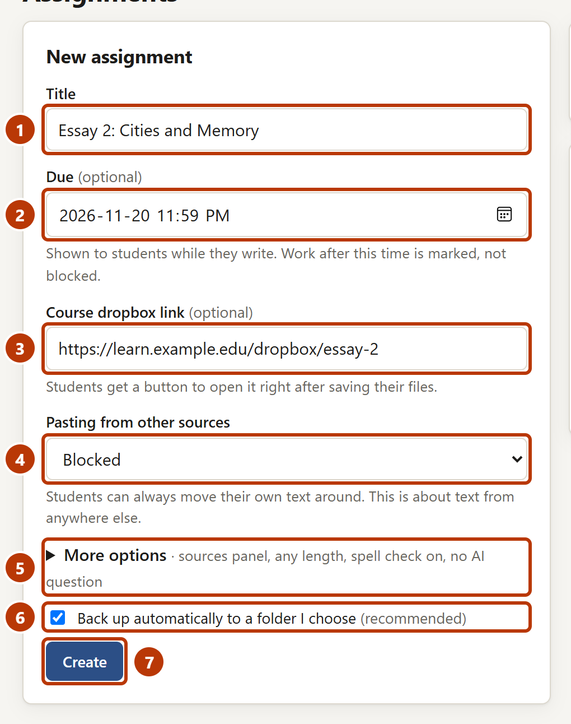
Figure 1. The New assignment form
Number | Item | What it is for
1 | Title | The title that students see.
2 | Due | Students see the due date while they write. Draftwork does not stop work after the due date. It shows when each part was written.
3 | Course dropbox link | After students click Ready to submit…, they get a button that opens this link.
4 | Pasting from other sources | Blocked stops students from pasting text from other places. Students can always move their own text.
5 | More options | Shows the other settings. The text after it shows the current settings.
6 | Back up automatically to a folder I choose | Shows only when you do not have a backup folder. Leave it selected to choose a folder when you click Create.
7 | Create | Makes the assignment.

More options
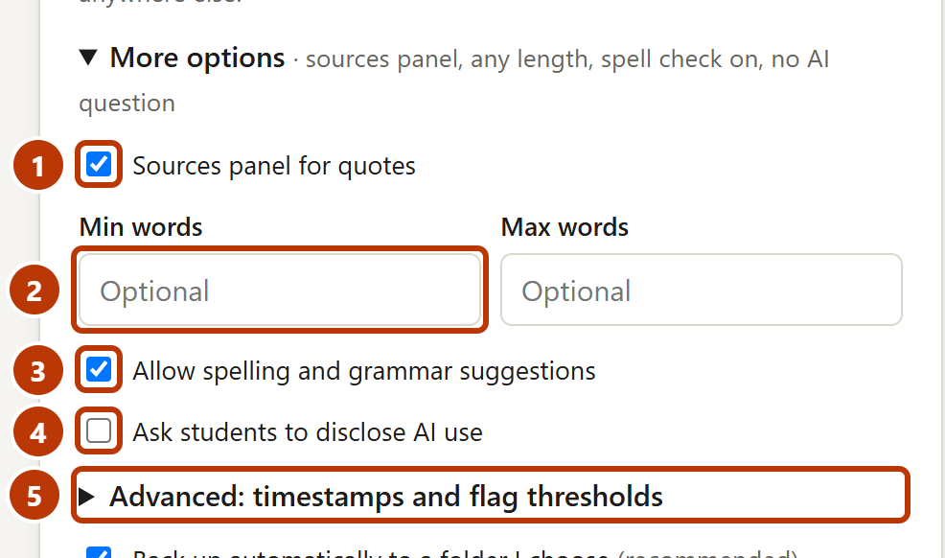
Figure 2. More options
Number | Item | What it is for
1 | Sources panel for quotes | Gives students a panel where they can paste quotes. Quotes are marked in the record.
2 | Min words and Max words | The required length. Students see their progress.
3 | Allow spelling and grammar suggestions | Turns the spelling check of the browser on or off.
4 | Ask students to disclose AI use | Students must say if they used AI tools, and how. You see the answer with their work.
5 | Advanced | The timestamp service and the flag thresholds. Usually you do not change these.

NOTE: In Advanced, the setting Test assignment is only for practice. Do not use it for a real assignment.

Change an assignment
You cannot edit an assignment after you make it. Its settings are part of its link. To change a setting, for example the due date, make a copy and change the copy.
- Click Assignments.
- In Your assignments, find the assignment. Click More ▾.
- Click Make a copy. The New assignment form shows the settings of the assignment.
- Change the settings.
- Click Create.
- Give the new link to your students. Use Instructions for students for the new assignment.

CAUTION: Students who started with the old link continue to use the old settings. If no student has started, you can remove the old assignment: click More ▾, then Remove from this browser.

Back up your assignments and notes
Draftwork keeps your assignments and your check-in notes in your web browser. If you clear the browsing data, or use a different browser or computer, they are not there. Use a backup to keep them safe.
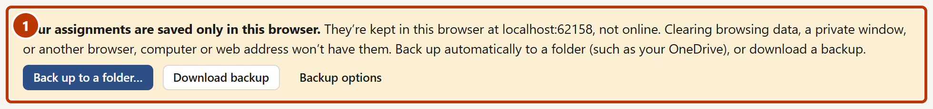
Figure 3. The message that shows when you do not have a backup

Back up automatically to a folder (Chrome and Edge)
- Click Assignments.
- In Back up, share & merge, click Back up automatically to a folder….
- Select a folder, for example a folder in your OneDrive.
- When the browser asks, let Draftwork save changes in the folder.

Draftwork then saves a backup in the folder each time that something changes. It also keeps one copy for each day.
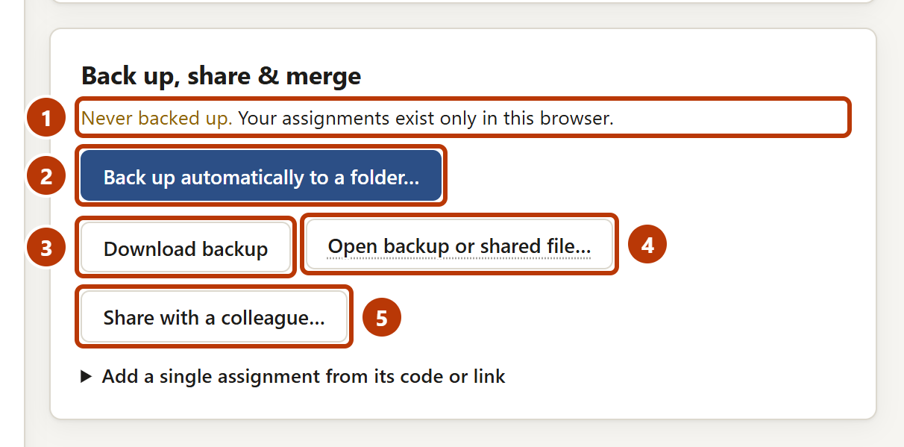
Figure 4. Back up, share & merge
Number | Item | What it is for
1 | Status | Tells you when the last backup was made.
2 | Back up automatically to a folder… | Saves a backup in a folder that you choose, each time that something changes.
3 | Download backup | Downloads one backup file. Use this in browsers other than Chrome and Edge.
4 | Open backup or shared file… | Adds the contents of a backup or a shared file to what you have. Nothing is removed.
5 | Share with a colleague… | Makes a file with some assignments for a co-teacher or a teaching assistant.

NOTE: After the browser restarts, the message Allow backups to continue can show. Click Allow.

Use your assignments on a different computer
- On the second computer, open Draftwork in Chrome or Edge.
- Click Open assignments.
- Click Back up automatically to a folder….
- Select the same folder as on the first computer. Draftwork adds the backup from the folder to this computer.

NOTE: If you use a different browser, click Open backup or shared file… and select a backup file that you downloaded.

Give the instructions to your students
Each assignment has a link. Students open the link to start. The button Instructions for students gives you the link and the steps for students in one text.

Tell your students what to upload
When a student clicks Ready to submit…, Draftwork gives the student two files: a .draftwork file and a Word document. You must tell your students which files to upload. Select one of these options in What should students upload?. The instructions change to agree with your selection.
- Both files: .draftwork and Word: use this if you want to see the work in the preview of your course site, for example in Canvas SpeedGrader, before you open the submissions in Draftwork.
- Only the .draftwork file: use this if you do not need the preview.

CAUTION: The .draftwork file is the record of the work. The Word document is only a copy for the preview. A student can change the Word document after saving it, and Draftwork does not examine it. Read the submitted document in Draftwork before you make a decision about the work.
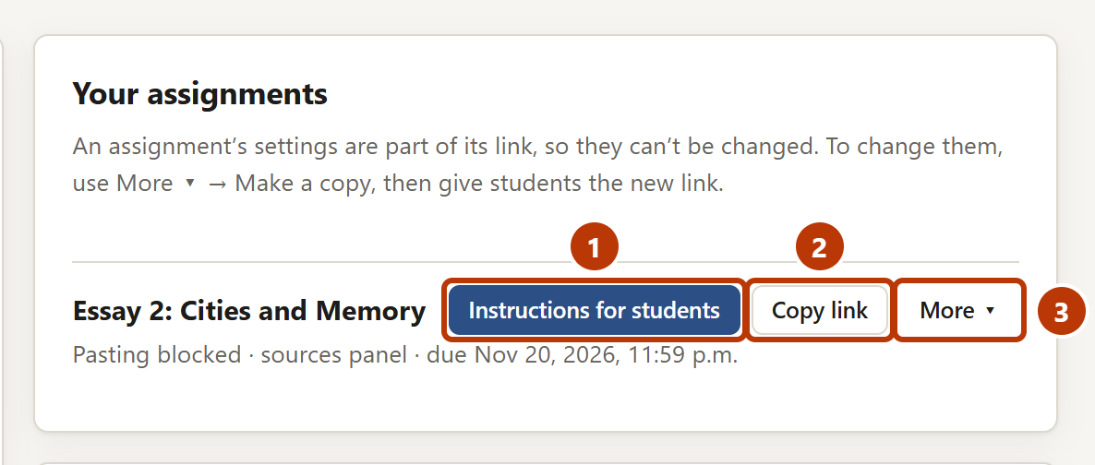
Figure 5. An assignment in Your assignments
Number | Item | What it is for
1 | Instructions for students | Shows the instructions to paste into your course site.
2 | Copy link | Copies only the link to the assignment.
3 | More ▾ | Make a copy to change the settings, copy the short code, try the assignment as a student, or remove it from this browser.

- Click Assignments.
- In Your assignments, find the assignment.
- Click Instructions for students.
- In What should students upload?, select an option.
- Click Copy instructions.
- Paste the text into the assignment in your course site.
- Optional: click Printable handout for students and print the handout.

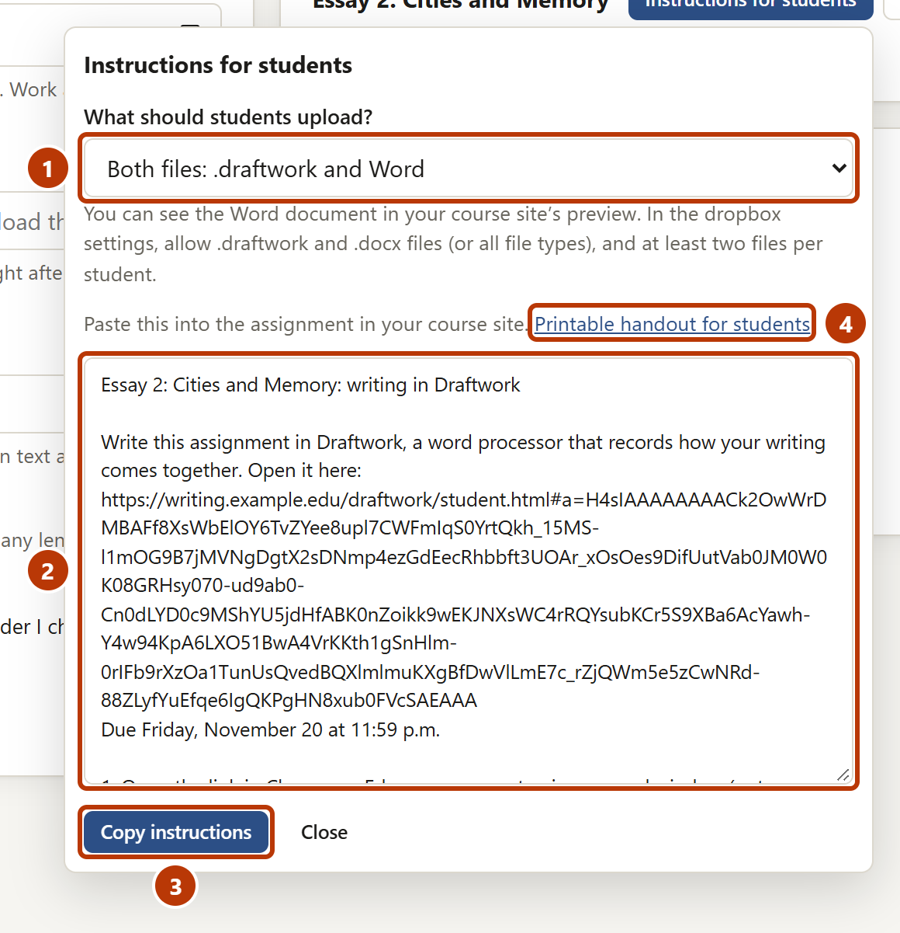
Figure 6. Instructions for students
Number | Item | What it is for
1 | What should students upload? | Both files, or only the .draftwork file. Draftwork keeps your last selection.
2 | Instructions | The link, the due date and the steps for students. The text uses the same words that students see in Draftwork.
3 | Copy instructions | Copies the text.
4 | Printable handout for students | Opens a one-page guide for students that you can print.

Prepare the dropbox in your course site
- In your course site, open the settings of the assignment dropbox.
- Set the dropbox to accept .draftwork files, or all file types. If students upload both files, the dropbox must also accept .docx files.
- If students upload both files, set the dropbox to accept two files for each student.
- Save the settings.

CAUTION: Make sure that the dropbox accepts the files that students upload. If it does not, students cannot upload their work.

See what your students see
Before you give the link to your students, try the student editor. Then you can answer the questions of your students more easily.
- Open Draftwork. Click Try the student editor.
- Type a name. Select the check box I understand what’s recorded. Click Start, then Yes, start writing.
- Write some sentences.
- Click Preview to see what your students see before they save their files.

NOTE: This practice assignment is not one of your assignments. To try one of your assignments, click More ▾ for the assignment, then click Try it as a student.

Open the submissions
- In your course site, download all submissions for the assignment as one zip file.
- In Draftwork, click Submissions.
- Drag the zip file onto the drop area. Or click the drop area and select the file.

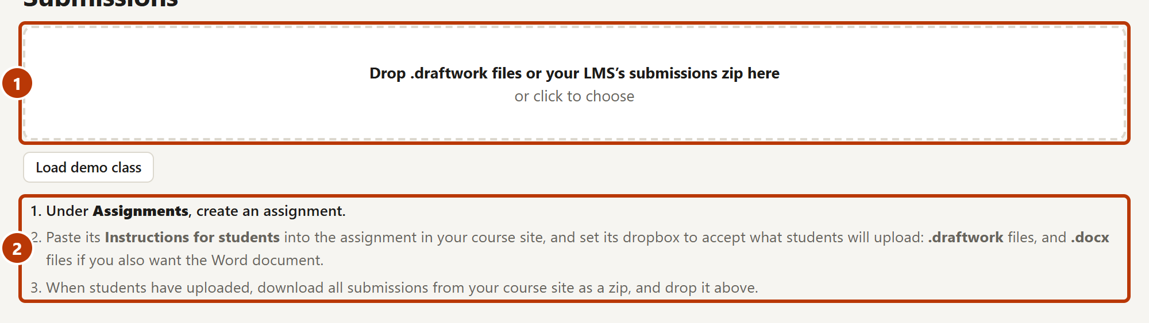
Figure 7. The Submissions page before you open files
Number | Item | What it is for
1 | Drop area | Drag the zip file or .draftwork files here, or click to select them.
2 | First steps | A short list of the steps. The current step is in bold. A completed step shows “done”.

NOTE: Draftwork reads the files in your browser. It does not upload them.
NOTE: If a student did not upload a .draftwork file, for example if the student uploaded only a Word document, a message shows the name of the student and the file. Ask the student to upload the .draftwork file. Draftwork does not show a message when a student uploads a Word document and a .draftwork file.

Find the submissions that need attention
Each submission has a colour. The colour shows how serious its flags are.
Colour | Label | What it means | What to do
Red | Major flags | A major flag, or three or more flags. | Read the report. Talk with the student.
Amber | Minor flags | One or two minor flags. | Read the flags. Ask a short question if necessary.
Green | No flags | Nothing unusual in how the work was written. | Read some of these submissions too. Green is not a decision.

- In Sort, select Most serious first.
- Click the first submission in the list.
- Read the report.
- Click Next → to go to the next submission. Next → follows the sort and the filter that you selected.

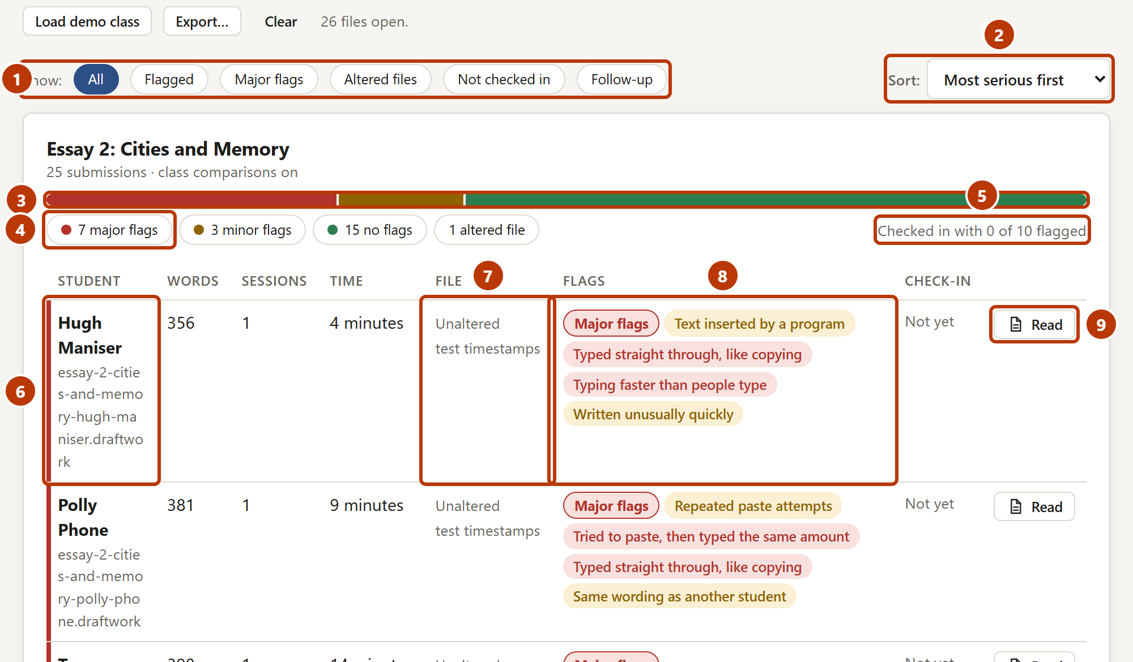
Figure 8. The list of submissions
Number | Item | What it is for
1 | Filters | Show all submissions, or only the flagged, major, altered, not checked in, or follow-up submissions.
2 | Sort | Name, Most serious first or Not checked in first.
3 | Summary bar | Red, amber and green parts show how many submissions have each colour. Click a part to show only those submissions.
4 | Counts | The number of submissions of each colour. Click a count to show only those submissions. Click again to show all.
5 | Check-in progress | How many flagged students you recorded answers for.
6 | Student | The name in the file, and the name from your course site. The coloured line at the left shows the colour of the submission.
7 | File | Unaltered or Altered. This shows only if the file was changed. It does not show who wrote the work.
8 | Flags | The colour label and the name of each flag. Point to a flag to read more.
9 | Read | Opens the submitted document.

Read a report
Click a submission to open its report. The report has two tabs: Overview and Document.
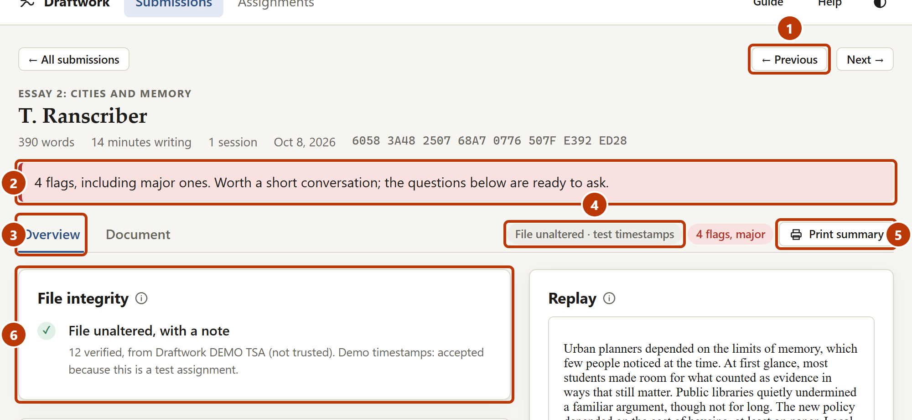
Figure 9. The top of a report
Number | Item | What it is for
1 | ← Previous and Next → | Go to the previous or the next submission in the list.
2 | Summary | One sentence that tells you what to do: nothing, a short question, or a conversation.
3 | Overview and Document | Overview shows the checks, flags, writing process, questions and replay. Document shows the submitted document.
4 | Labels | The status of the file and the number of flags.
5 | Print summary | Prints a one-page record of the review, or saves it as a PDF.
6 | File integrity | Shows if the file is an unaltered Draftwork record. Click it to see the five checks.

CAUTION: Do not read File unaltered as approval. It shows only that the file was not changed after it was written. It does not show who wrote the work.
NOTE: The screenshots in this guide show a sample class. Their files show “test timestamps” because they were made for practice. Real assignments do not show this note.

Read a flag
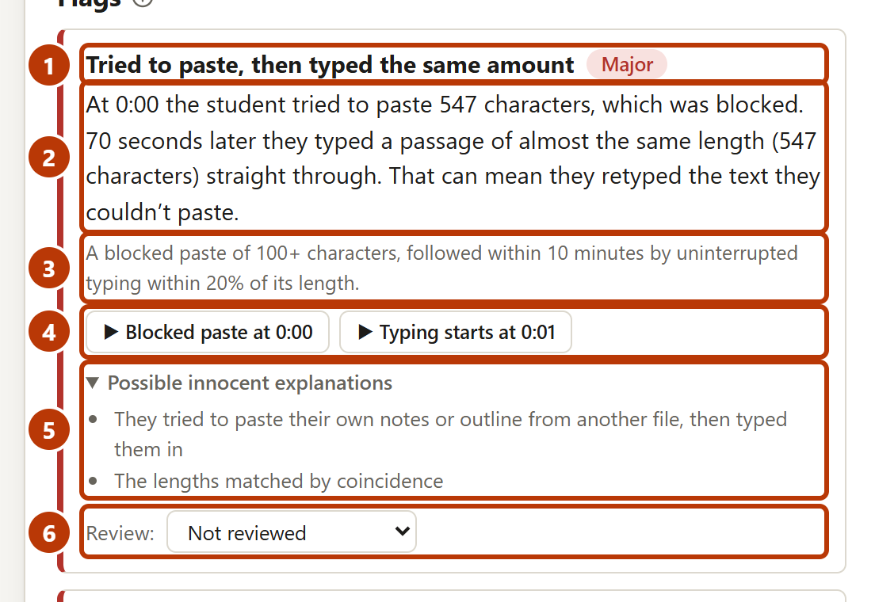
Figure 10. A flag
Number | Item | What it is for
1 | Name and severity | What happened, and Major or Minor.
2 | Explanation | What Draftwork found, in plain words.
3 | Measurement | The numbers and the limit that caused the flag.
4 | Moments | Click a moment to show it in the replay.
5 | Possible innocent explanations | Usual reasons that are not misconduct. Think about them before you talk with the student.
6 | Review | Your decision after the conversation: Benign after check-in or Concern remains.

Types of flags
Flag | Severity | What it can mean
Tried to paste, then typed the same amount | Major | The student tried to paste text, then typed text of the same length.
Typed straight through, like copying | Major | A long passage was typed with no corrections at a steady speed, as when you copy text.
Typing faster than people type | Major | A program possibly typed the text.
Heavy quoting (more than half of the text) | Major | Most of the text came from the Sources panel.
Altered file (for example, “Submitted text doesn’t match its history”) | Major | The file was changed after it was written, or it was not made in Draftwork.
Repeated paste attempts | Minor | The student tried to paste text from other places three or more times.
Text inserted by a program | Minor | A script or a browser extension tried to put text into the essay. Draftwork stopped it.
Large text entered in one go | Minor | A large block of text arrived in one action.
Left the window, then wrote quickly | Minor | The student read something in another window, then typed quickly.
Same wording as another student | Minor | A long passage is the same as in a different submission.
Written unusually quickly | Minor | The writing time was much shorter than for the rest of the class.
Unnaturally even typing | Minor | The typing rhythm was much more regular than for the rest of the class.
Stretch without timestamps | Minor | For a long time, no timestamps were recorded. Usually the connection stopped.

NOTE: Three or more minor flags together make a submission red.

See how the work was written

The writing process graph
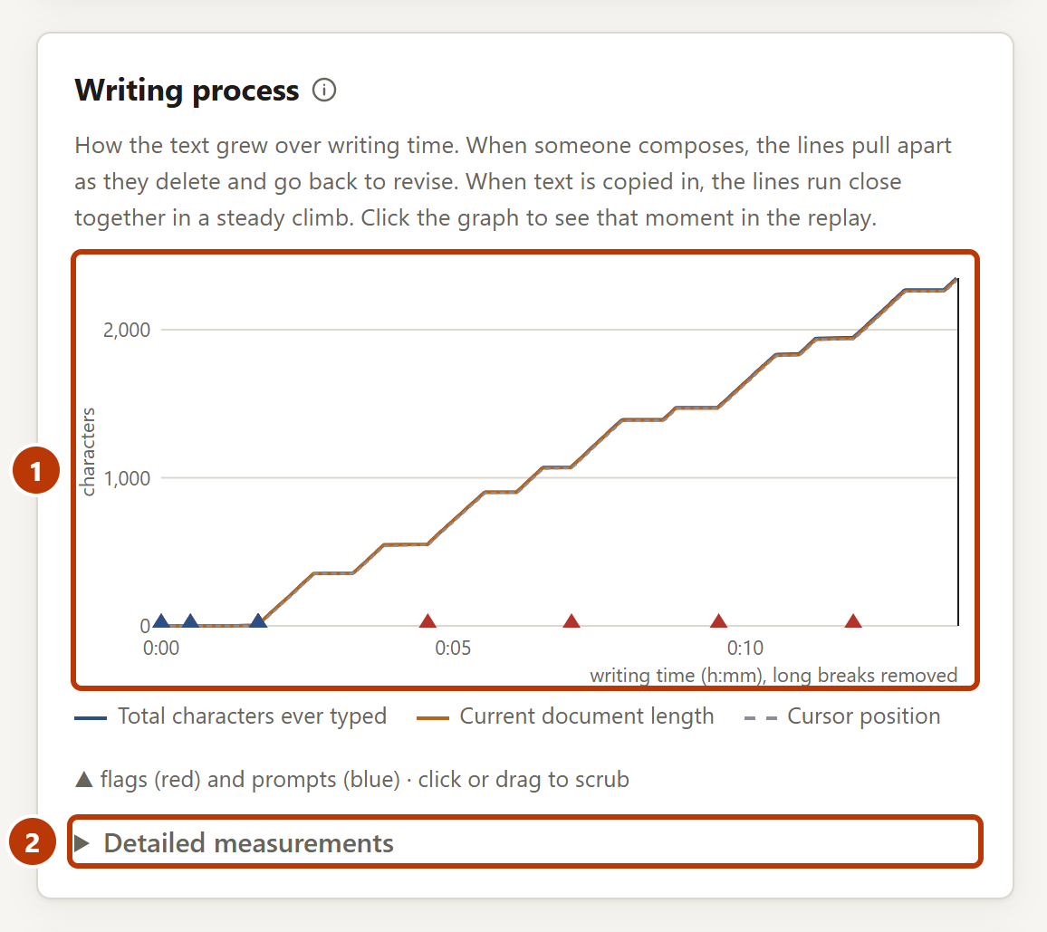
Figure 11. Writing process
Number | Item | What it is for
1 | Graph | Shows how the text grew. When a student composes, the lines move apart because the student deletes and revises. When text is copied, the lines stay together. Click the graph to show that moment in the replay.
2 | Detailed measurements | The numbers that the flags use, and where this file is in the class. Usually you do not need them.

The replay
- Click a moment button in a flag or a question. Or click the graph.
- Click Play to see the writing from that moment.
- To change the speed, select a speed in the speed list.
- To stop, click Pause.

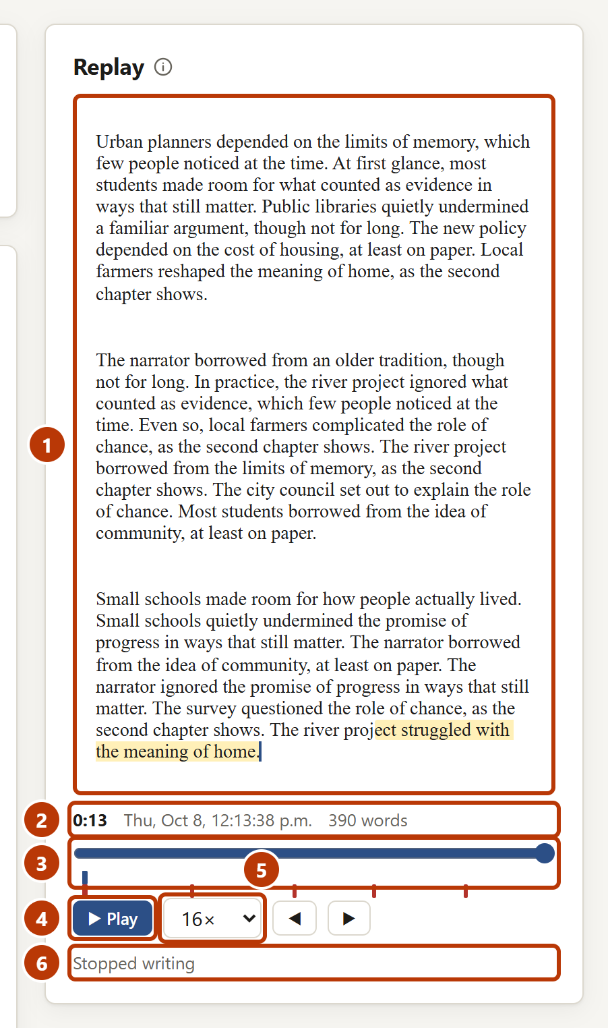
Figure 12. The replay
Number | Item | What it is for
1 | Document | The document at the selected moment. New text is highlighted.
2 | Time | The writing time, the date and the word count at that moment.
3 | Slider | Drag it to move through the writing. The small marks show flags and questions.
4 | Play | Plays the writing. Long breaks are not shown.
5 | Speed | The speed of the replay, for example 16×.
6 | Last change | What the student did at that moment, for example “Typed” or “Deleted”.

NOTE: You can scroll the replay while it plays. To go back to the place where the writing occurs, click Follow writing.

Talk with the student
Questions to ask gives you questions about specific moments in the writing. Questions about flags come first. A student who wrote the work can usually answer them quickly.
- Read the questions.
- Click Show at to see each moment in the replay.
- Ask the student two or three of the questions. Ask openly.
- Do not tell the student what was flagged before the student answers.
- In the box below each question, type what the student said.
- In the list next to the box, select the outcome.
- For each flag, in Review, select your decision.
- Optional: click Print summary to print a record or save it as a PDF.

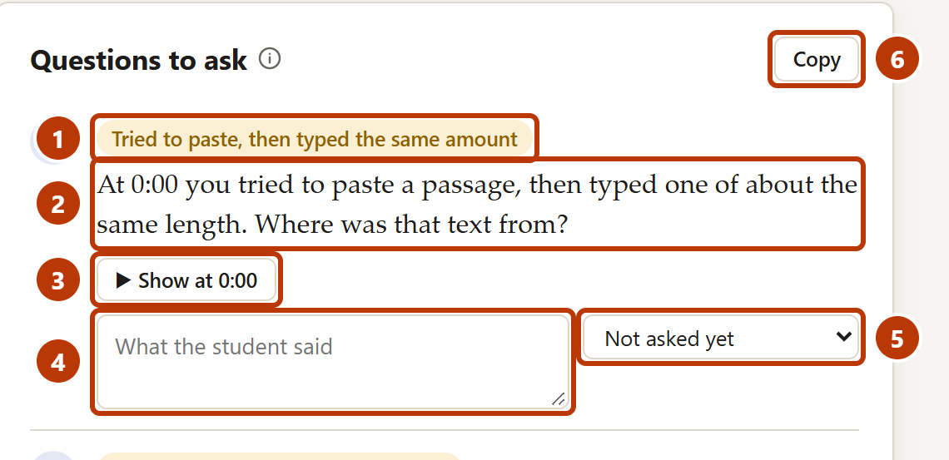
Figure 13. Questions to ask
Number | Item | What it is for
1 | Label | The flag or the type of moment that the question is about.
2 | Question | A question that you can read to the student.
3 | Show at | Shows the moment in the replay.
4 | Answer box | Type what the student said. Draftwork keeps it in your browser and in your backup.
5 | Outcome | Explained convincingly, Answer unclear or Needs follow-up.
6 | Copy | Copies the questions as a numbered list.

NOTE: If there is time, open More questions for more moments to ask about.
CAUTION: Follow the academic integrity policy of your institution for any further action. A flag or a red colour is not evidence of misconduct on its own.

Read the submitted document
- In a report, click the Document tab.
- Read the document as the student formatted it.
- Optional: use the buttons to copy, download or print the document.

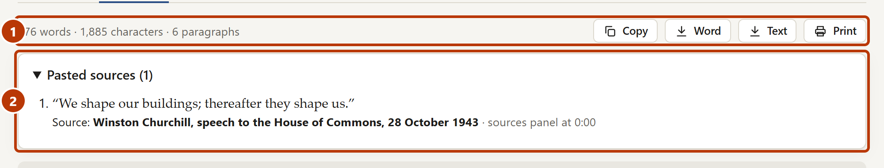
Figure 14. The Document tab
Number | Item | What it is for
1 | Toolbar | The word count, and the buttons Copy, Word, Text and Print.
2 | Pasted sources | Text that the student pasted from other places, with the source that the student gave.

Share with a colleague
Use this when a co-teacher or a teaching assistant reviews the same class.
- Click Assignments.
- Click Share with a colleague….
- Select the assignments to share.
- Optional: select Include my check-in notes.
- Click Download file.
- Send the file to your colleague.

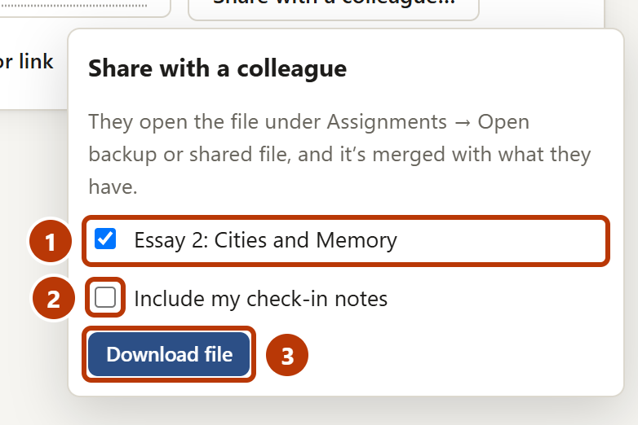
Figure 15. Share with a colleague
Number | Item | What it is for
1 | Assignments | Select the assignments to share.
2 | Include my check-in notes | Adds your notes for the students in these assignments.
3 | Download file | Makes the file to send.

Your colleague clicks Open backup or shared file… and selects the file. Draftwork adds the contents to what your colleague has. Nothing is removed. Notes about the same student are combined.

Export a spreadsheet
- Click Submissions.
- Click Export….
- Click Spreadsheet with names, or click Anonymised, for calibration.

NOTE: The anonymised spreadsheet does not contain names, file codes or your notes. You can share it to help improve the flag settings.

If you have a problem
Problem | Possible cause | What to do
Your assignments are not there. | You use a different browser, a private window or a different computer, or the browsing data was cleared. | Click Back up automatically to a folder… and select your backup folder. Or click Open backup or shared file… and select a backup file.
The message Allow backups to continue shows. | The browser restarted. | Click Allow.
A student is not in the list. | The student uploaded only a different file, or did not upload. | Read the message about other files at the top of the list. Ask the student to upload the .draftwork file.
The File column shows Altered. | The file was changed after it was written, or it was not made in Draftwork. | Read the report. Ask the student how they saved and uploaded the file.
The File column shows “assignment not in your list”. | The assignment is not in Your assignments in this browser. | Add the assignment: open your backup, or in Back up, share & merge, use Add a single assignment from its code or link.
The text “class comparisons need 15” shows. | Fewer than 15 submissions are open. | Open all the submissions for the assignment. Two flags compare students with the class.
Students cannot upload their files. | The dropbox does not accept .draftwork files or .docx files, or it accepts only one file. | Change the dropbox settings to accept these file types, and two files for each student.
You cannot see a preview in the course site. | The student uploaded only the .draftwork file. | Select Both files: .draftwork and Word in Instructions for students, and give the new text to your students. Or open the submission in Draftwork.
A setting of an assignment is wrong, for example the due date. | You cannot edit an assignment. | Click More ▾, then Make a copy. Change the setting. Click Create. Give the new link to your students.
A student sees the draft of a different student. | The two students used the same browser on a shared computer. | Tell the student to click Start my own draft. The draft of the other student is not deleted.
A student lost their draft. | The student used a private window, or cleared the browsing data. | Ask the student for their last saved file. Tell the student to use a normal window and to click Save frequently.

For more help, click Help or Guide at the top of the Draftwork page.

Words used in this guide
Word | Meaning
Check-in | A short conversation with a student about some moments in their writing.
.draftwork file | The file that a student uploads. It contains the work and the record of how it was written.
Word document | A copy of the work as a .docx file, for the preview in your course site. Draftwork does not examine it.
File integrity | Checks that show if a file is an unaltered Draftwork record. They do not show who wrote the work.
Flag | A moment or a pattern that is worth a question. A flag is not evidence on its own.
Major flag, minor flag | A major flag is a strong sign on its own. A minor flag often has an innocent explanation.
Replay | A play-back of the writing, from the first keystroke to the submitted text.
Timestamp | A record of time from an online clock service. It shows when the writing occurred.
Zip file | One file that contains many files. Course sites use it for “download all submissions”.

